- Create a class Vehicle, write a method cost() in this class. Create two classes Bus and Train which have their own display() methods and inherit from Vehicle class. Create objects of Bus and Train class and call cost() and display() methods.
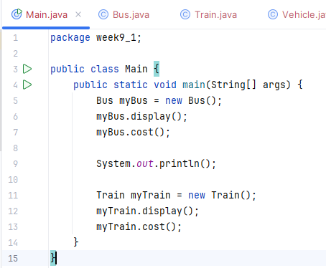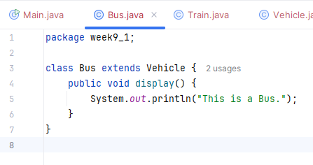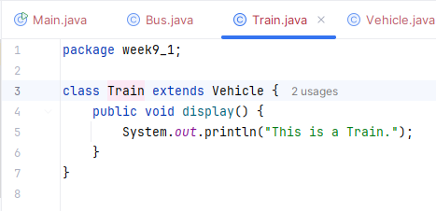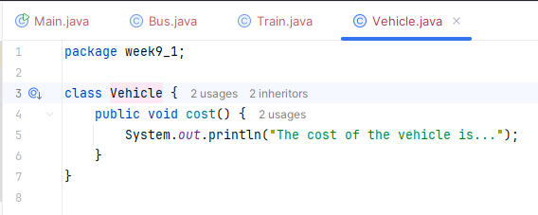
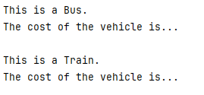
- Create class University which has data members- name and ranking. Create class Faculty that extends University class has data member- name and method- Details(). Create a new class Department which is derived from Faculty and has data member- name, chairman and method- Details() and Display() where Display() method calls Details() methods of both Faculty and Department class in its body. Create an object of Department class to Display() method and University ranking.
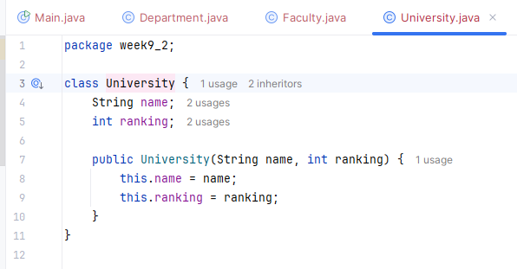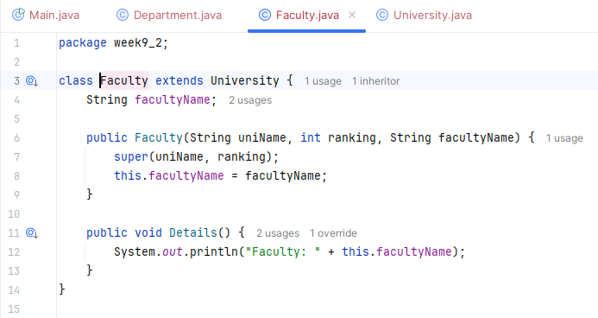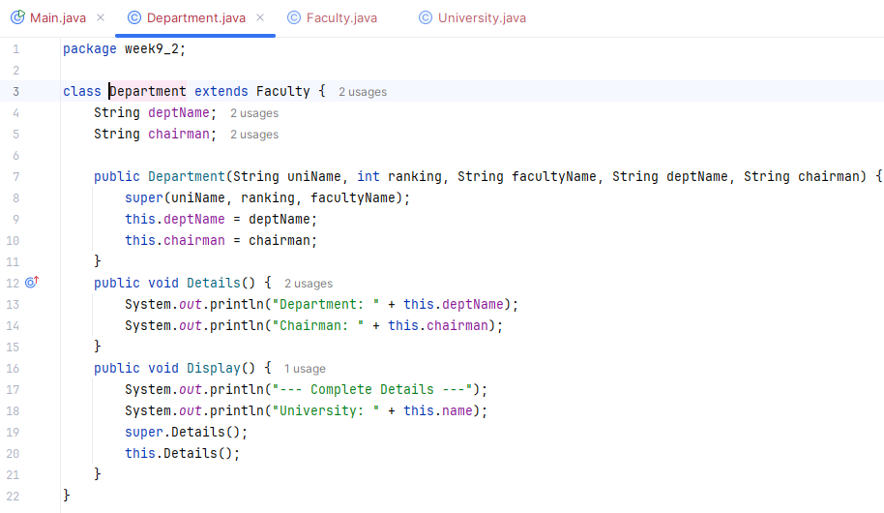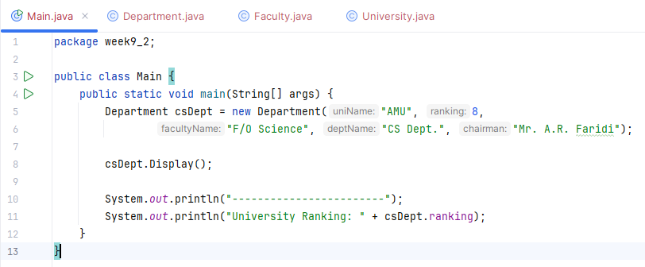
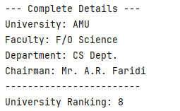
- Create class Account (Data members- Id, Account_holder_name, Address; Methodsdeposit(), withdraw()). Create two static methods in Account calculateSimpleInterest() and calculateCompoundInterest() and implement them.
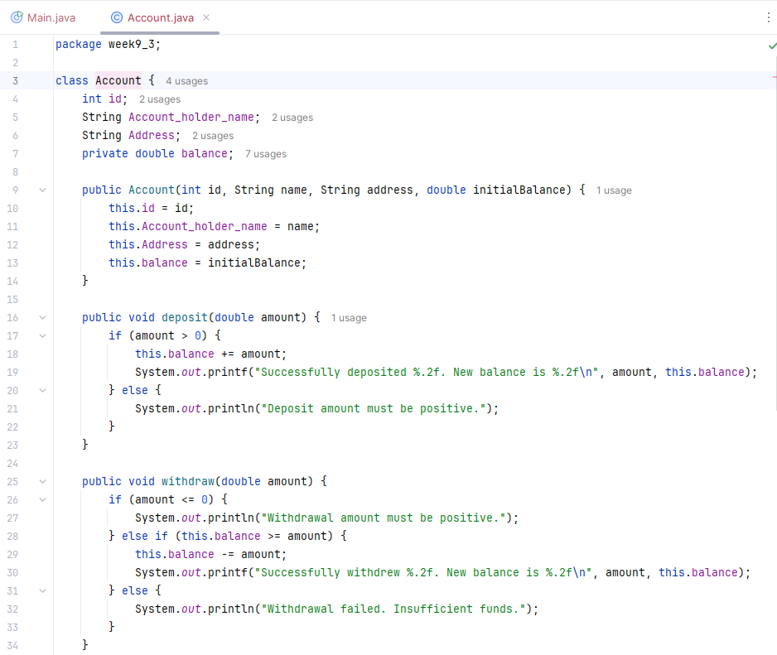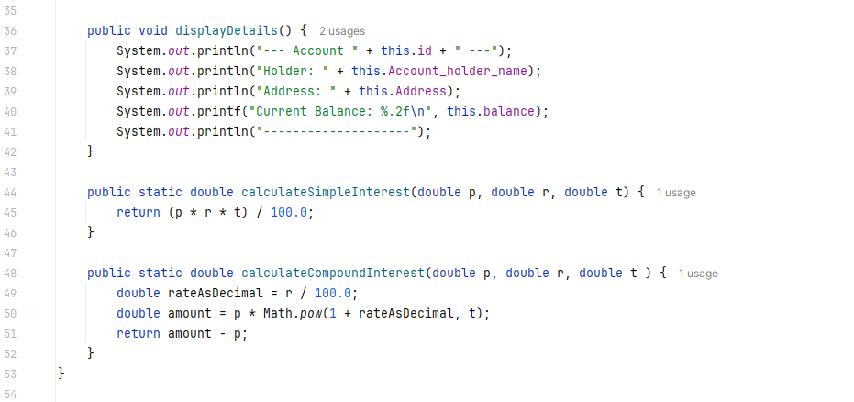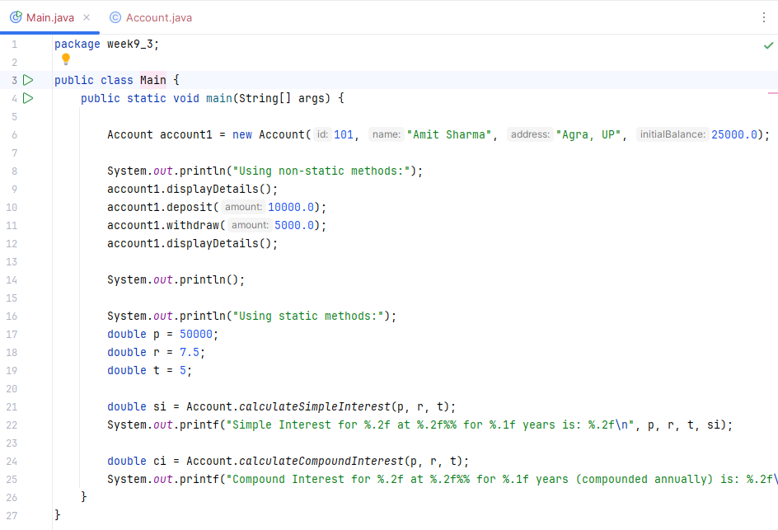
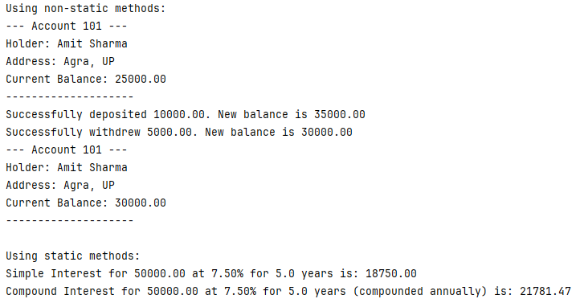
- Create class Account (Data members- Id, Account_holder_name, Address; Methodsdeposit(), withdraw()). Declare deposit() and withdraw() as abstract methods. Declare Account class as abstract. (Create constructor in Account as well).
- Create two children of Account- Saving (Data Members- Min_balance; Methodsdisplay(), deposit(), withdraw()) and Current (Data Members- Max_withdrawl_limit; Methods-display(),deposit(), withdraw()) . Create constructors for both classes. Implementation of deposit() and withdraw() should be specific to Saving and Current class. Create objects of Saving and Current class and display them
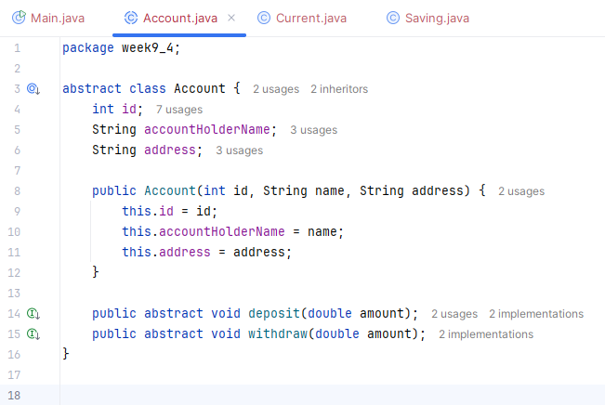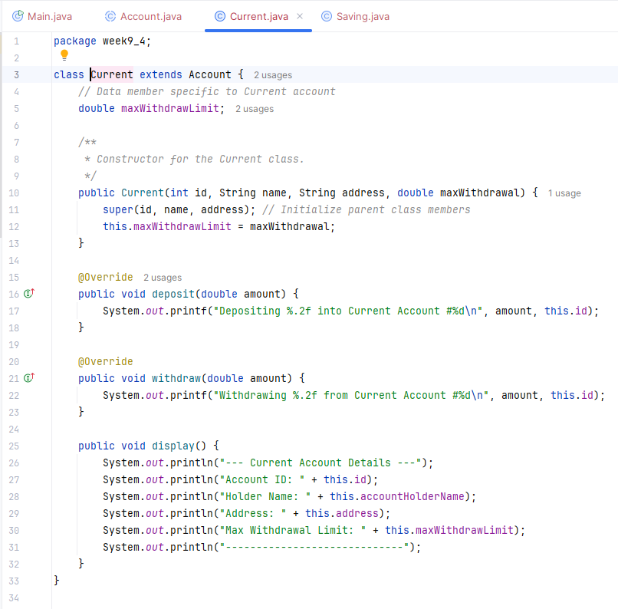
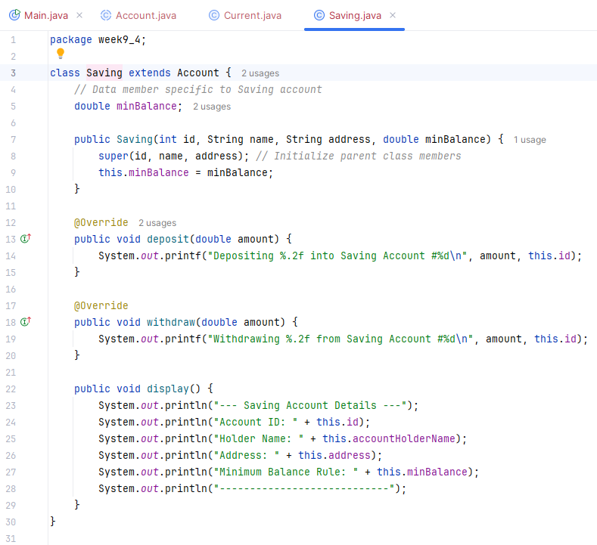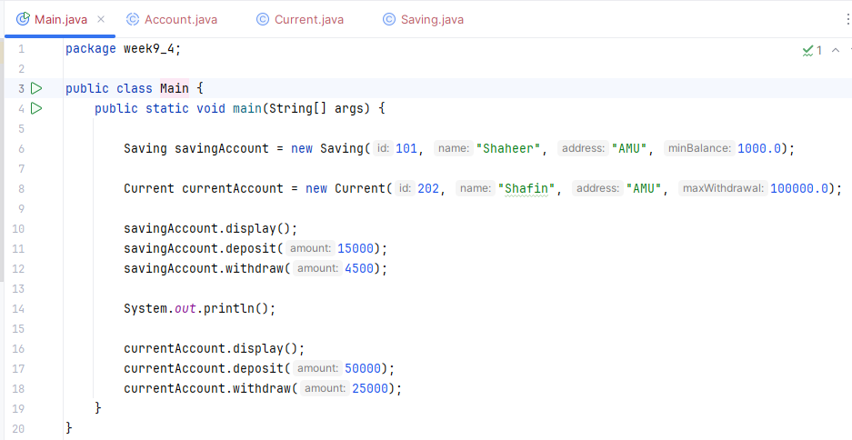
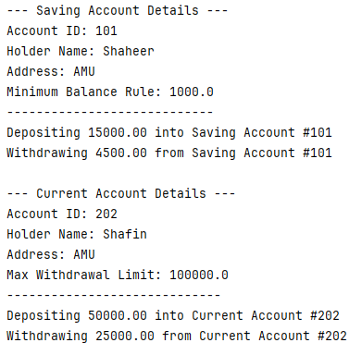
- Create a class Shape with a method area(). Create two derived classes Rectangle and Circle that extend Shape. Each class should override the area() method to calculate the area of the respective shape. Create objects of Rectangle and Circle and call their area() methods.
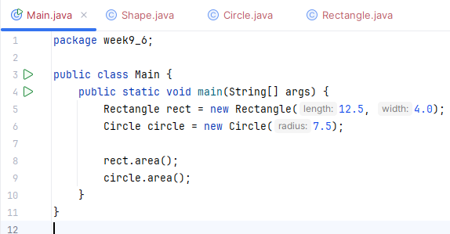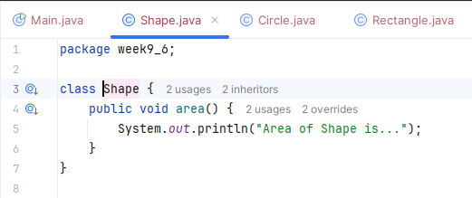
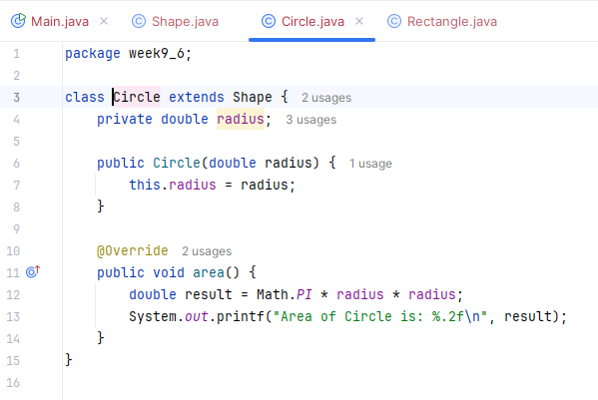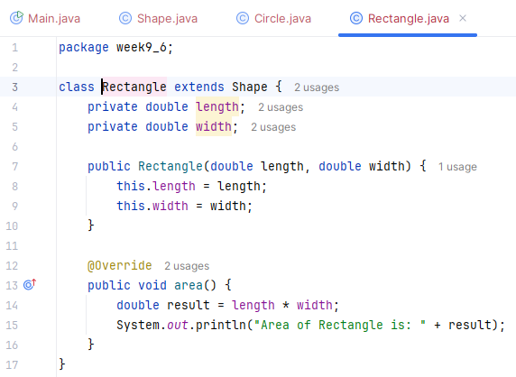
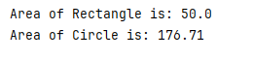
- Create a class Employee with data members: name, salary, and a method showDetails(). Create a class Manager that extends Employee with an additional data member department. Override the showDetails() method in Manager to display all details, including department. Create an object of Manager and call showDetails().
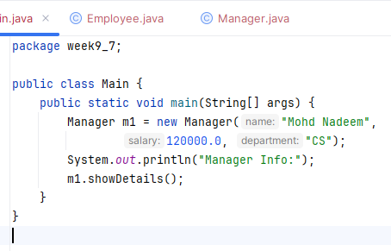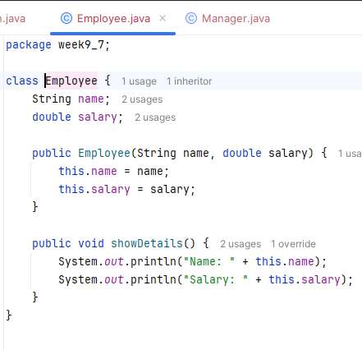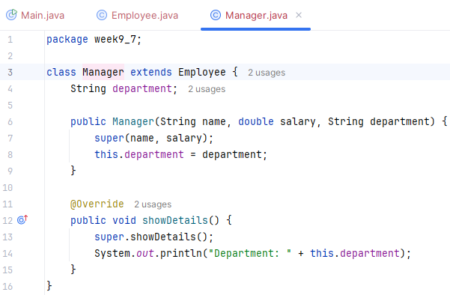
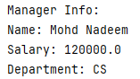
- Create an abstract class Appliance with data members brand, power and abstract methods turnOn() and turnOff(). Create two derived classes WashingMachine and Refrigerator that provide their own implementations of turnOn() and turnOff(). Create objects of WashingMachine and Refrigerator and call their methods.
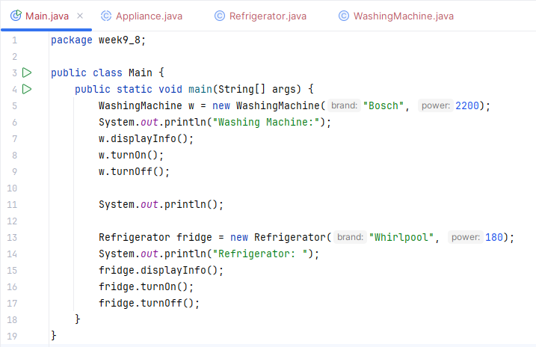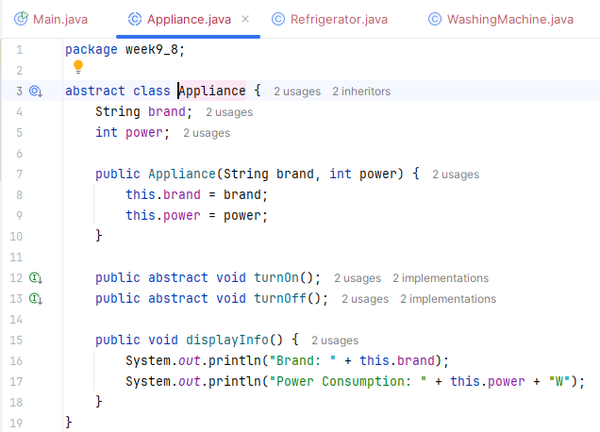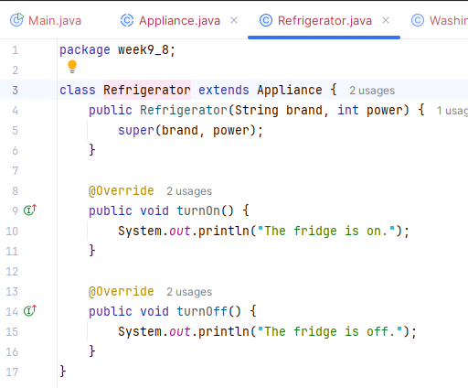
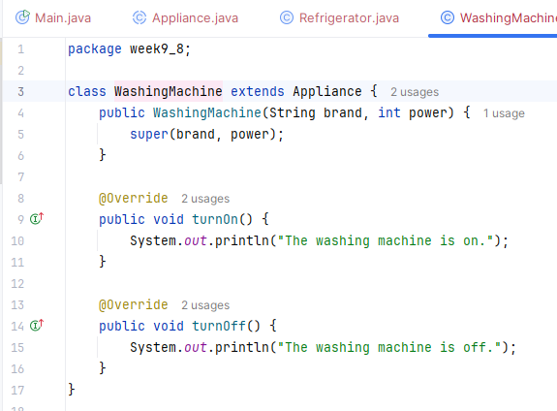
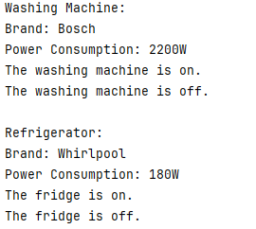
- Create a class MathOperations with two static methods: findGCD(int a, int b) to calculate the greatest common divisor and findLCM(int a, int b) to calculate the least common multiple. Call these methods without creating an object of MathOperations.
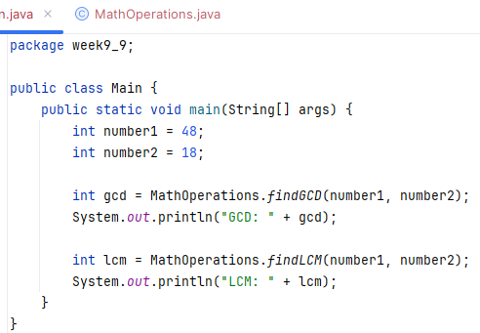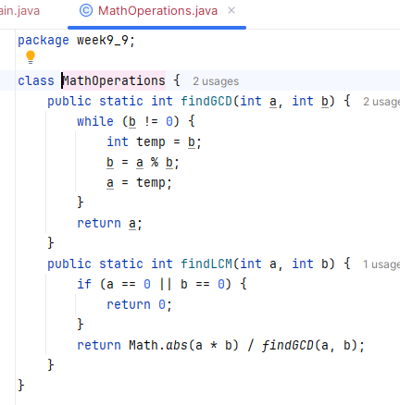
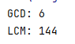
- Create a class Student with data members rollNo, name, marks. Add a static variable schoolName. Create static method changeSchoolName() to update schoolName. Demonstrate how the static variable is shared among all objects.
